**Comparative Studies of Copy Number Variation  
Detection Methods for Next-Generation Sequencing  
Technologies**

This paper deals with various CNV detection methods and their performance on various variables and their combinations.

To measure performance the variables we use are:

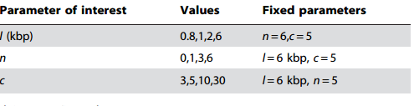

Here, l = length of a single copy number

n = number of blocks in a fixed length

c = coverage of copy numbers

We examine the methods over two types of data. Simulated data and real data. Simulated data are made with maintenance of the above mentioned variables. The performance graphs are below:

